[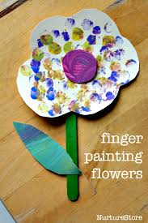](https://www.google.com/url?sa=i&url=https%3A%2F%2Fwww.pinterest.com%2Fpin%2F546202261039179822%2F&psig=AOvVaw1X-8jqbPRmQSdldRw-8GXJ&ust=1590676315537000&source=images&cd=vfe&ved=0CAIQjRxqFwoTCJDAzJuh1OkCFQAAAAAdAAAAABAD)[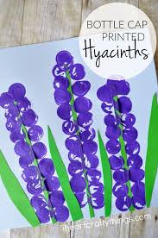](https://www.google.com/url?sa=i&url=https%3A%2F%2Fwww.pinterest.com%2Fpin%2F509962357787314873%2F&psig=AOvVaw1X-8jqbPRmQSdldRw-8GXJ&ust=1590676315537000&source=images&cd=vfe&ved=0CAIQjRxqFwoTCJDAzJuh1OkCFQAAAAAdAAAAABAJ)

Sensory suggestions: Pick some leaves or flowers from outside and use them to paint with

Get some seeds and plant some flowers- let the students touch the dirt and help dig a hole, count the seeds as you drop them in, and water them!

Make a sensory bin made out of dirt seeds and flowers